Duke Comprehensive Cancer Center

Duke Comprehensive Cancer Center

Duke Comprehensive Cancer Center

Duke Comprehensive Cancer Center

Duke Comprehensive Cancer Center

Duke Comprehensive Cancer Center

Duke Comprehensive Cancer Center

Duke Comprehensive Cancer Center

Duke Comprehensive Cancer Center

Duke Comprehensive Cancer Center

Duke Comprehensive Cancer Center

Duke Comprehensive Cancer Center

Duke Comprehensive Cancer Center

Duke Comprehensive Cancer Center

Duke Comprehensive Cancer Center

Duke Comprehensive Cancer Center

Duke Comprehensive Cancer Center

Duke Comprehensive Cancer Center

Duke Comprehensive Cancer Center

Duke Comprehensive Cancer Center

Duke Comprehensive Cancer Center

Duke Comprehensive Cancer Center

Duke Comprehensive Cancer Center

Duke Comprehensive Cancer Center

Duke Comprehensive Cancer Center

Duke Comprehensive Cancer Center

Duke Comprehensive Cancer Center

Duke Comprehensive Cancer Center

Duke Comprehensive Cancer Center

Duke Comprehensive Cancer Center

Duke Comprehensive Cancer Center

Duke Comprehensive Cancer Center

Duke Comprehensive Cancer Center

Duke Comprehensive Cancer Center

Duke Comprehensive Cancer Center

Duke Comprehensive Cancer Center

Duke Comprehensive Cancer Center

Duke Comprehensive Cancer Center

Duke Comprehensive Cancer Center

Duke Comprehensive Cancer Center

Duke Comprehensive Cancer Center

Duke Comprehensive Cancer Center

Duke Comprehensive Cancer Center

Duke Comprehensive Cancer Center

Duke Comprehensive Cancer Center

Duke Comprehensive Cancer Center

Duke Comprehensive Cancer Center

Duke Comprehensive Cancer Center

Duke Comprehensive Cancer Center

Duke Comprehensive Cancer Center

Duke Comprehensive Cancer Center

Duke Comprehensive Cancer Center

Duke Comprehensive Cancer Center

Duke Comprehensive Cancer Center

Duke Comprehensive Cancer Center

Duke Comprehensive Cancer Center

Duke Comprehensive Cancer Center

Duke Comprehensive Cancer Center

Duke Comprehensive Cancer Center

Duke Comprehensive Cancer Center

Duke Comprehensive Cancer Center

Duke Comprehensive Cancer Center

Duke Comprehensive Cancer Center

Duke Comprehensive Cancer Center

Duke Comprehensive Cancer Center

Duke Comprehensive Cancer Center

Duke Comprehensive Cancer Center

Duke Comprehensive Cancer Center

Duke Comprehensive Cancer Center

Duke Comprehensive Cancer Center

Duke Comprehensive Cancer Center

Duke Comprehensive Cancer Center

Duke Comprehensive Cancer Center

Duke Comprehensive Cancer Center

Duke Comprehensive Cancer Center

Duke Comprehensive Cancer Center

Duke Comprehensive Cancer Center

Duke Comprehensive Cancer Center

Duke Comprehensive Cancer Center

Duke Comprehensive Cancer Center

Duke Comprehensive Cancer Center

Duke Comprehensive Cancer Center

Duke Comprehensive Cancer Center

Duke Comprehensive Cancer Center

Duke Comprehensive Cancer Center

Duke Comprehensive Cancer Center

Duke Comprehensive Cancer Center

Duke Comprehensive Cancer Center

Duke Comprehensive Cancer Center

Duke Comprehensive Cancer Center

Duke Comprehensive Cancer Center

Duke Comprehensive Cancer Center

Duke Comprehensive Cancer Center

Duke Comprehensive Cancer Center

Duke Comprehensive Cancer Center

Duke Comprehensive Cancer Center

Duke Comprehensive Cancer Center

Duke Comprehensive Cancer Center

Duke Comprehensive Cancer Center

Duke Comprehensive Cancer Center

Duke Comprehensive Cancer Center

Duke Comprehensive Cancer Center

Duke Comprehensive Cancer Center

Duke Comprehensive Cancer Center

Duke Comprehensive Cancer Center

Duke Comprehensive Cancer Center

Duke Comprehensive Cancer Center

Duke Comprehensive Cancer Center

Duke Comprehensive Cancer Center

Duke Comprehensive Cancer Center

Duke Comprehensive Cancer Center

Duke Comprehensive Cancer Center

Duke Comprehensive Cancer Center

Duke Comprehensive Cancer Center

Duke Comprehensive Cancer Center

Duke Comprehensive Cancer Center

Duke Comprehensive Cancer Center

Duke Comprehensive Cancer Center

Duke Comprehensive Cancer Center

Duke Comprehensive Cancer Center

Duke Comprehensive Cancer Center

Duke Comprehensive Cancer Center

Duke Comprehensive Cancer Center

Duke Comprehensive Cancer Center

Duke Comprehensive Cancer Center

Duke Comprehensive Cancer Center

Duke Comprehensive Cancer Center

Duke Comprehensive Cancer Center

C3PR –Core & Web
Technical Specification

Duke Comprehensive Cancer Center


Copyright and License page

Copyright Notice. Copyright 2006 Duke Comprehensive Cancer Center (“caBIG™ Participant”). C3PR was created with NCI funding and is part of the caBIG™ initiative. The software subject to this notice and license includes both human readable source code form and machine readable, binary, object code form (the “caBIG™ Software”).
This caBIG™ Software License (the “License”) is between caBIG™ Participant and You. “You (or “Your”) shall mean a person or an entity, and all other entities that control, are controlled by, or are under common control with the entity. “Control” for purposes of this definition means (i) the direct or indirect power to cause the direction or management of such entity, whether by contract or otherwise, or (ii) ownership of fifty percent (50%) or more of the outstanding shares, or (iii) beneficial ownership of such entity.
License. Provided that You agree to the conditions described below, caBIG™ Participant grants You a non-exclusive, worldwide, perpetual, fully-paid-up, no-charge, irrevocable, transferable and royalty-free right and license in its rights in the caBIG™ Software, including any copyright or patent rights therein that may be infringed by the making, using, selling, offering for sale, or importing of caBIG™ Software, to (i) use, install, access, operate, execute, reproduce, copy, modify, translate, market, publicly display, publicly perform, and prepare derivative works of the caBIG™ Software; (ii) make, have made, use, practice, sell, and offer for sale, and/or otherwise dispose of caBIG™ Software (or portions thereof); (iii) distribute and have distributed to and by third parties the caBIG™ Software and any modifications and derivative works thereof; and (iv) sublicense the foregoing rights set out in (i), (ii) and (iii) to third parties, including the right to license such rights to further third parties. For sake of clarity, and not by way of limitation, caBIG™ Participant shall have no right of accounting or right of payment from You or Your sublicensees for the rights granted under this License. This License is granted at no charge to You. Your downloading, copying, modifying, displaying, distributing or use of caBIG™ Software constitutes acceptance of all of the terms and conditions of this Agreement. If you do not agree to such terms and conditions, you have no right to download, copy, modify, display, distribute or use the caBIG™ Software.
Your redistributions of the source code for the caBIG™ Software must retain the above copyright notice, this list of conditions and the disclaimer and limitation of liability of Article 6 below. Your redistributions in object code form must reproduce the above copyright notice, this list of conditions and the disclaimer of Article 6 in the documentation and/or other materials provided with the distribution, if any.
Your end-user documentation included with the redistribution, if any, must include the following acknowledgment: “This product includes software developed by Duke Comprehensive Cancer Center.” If You do not include such end-user documentation, You shall include this acknowledgment in the caBIG™ Software itself, wherever such third-party acknowledgments normally appear.
You may not use the names “Duke Comprehensive Cancer Center”, “The National Cancer Institute”, “NCI”, “Cancer Bioinformatics Grid” or “caBIG™” to endorse or promote products derived from this caBIG™ Software. This License does not authorize You to use any trademarks, service marks, trade names, logos or product names of either caBIG™ Participant, NCI or caBIG™, except as required to comply with the terms of this License.
For sake of clarity, and not by way of limitation, You may incorporate this caBIG™ Software into Your proprietary programs and into any third party proprietary programs. However, if You incorporate the caBIG™ Software into third party proprietary programs, You agree that You are solely responsible for obtaining any permission from such third parties required to incorporate the caBIG™ Software into such third party proprietary programs and for informing Your sublicensees, including without limitation Your end-users, of their obligation to secure any required permissions from such third parties before incorporating the caBIG™ Software into such third party proprietary software programs. In the event that You fail to obtain such permissions, You agree to indemnify caBIG™ Participant for any claims against caBIG™ Participant by such third parties, except to the extent prohibited by law, resulting from Your failure to obtain such permissions.
For sake of clarity, and not by way of limitation, You may add Your own copyright statement to Your modifications and to the derivative works, and You may provide additional or different license terms and conditions in Your sublicenses of modifications of the caBIG™ Software, or any derivative works of the caBIG™ Software as a whole, provided Your use, reproduction, and distribution of the Work otherwise complies with the conditions stated in this License.
THIS caBIG™ SOFTWARE IS PROVIDED "AS IS" AND ANY EXPRESSED OR IMPLIED WARRANTIES (INCLUDING, BUT NOT LIMITED TO, THE IMPLIED WARRANTIES OF MERCHANTABILITY, NON-INFRINGEMENT AND FITNESS FOR A PARTICULAR PURPOSE) ARE DISCLAIMED. IN NO EVENT SHALL THE DUKE COMPREHENSIVE CANCER CENTER OR ITS AFFILIATES BE LIABLE FOR ANY DIRECT, INDIRECT, INCIDENTAL, SPECIAL, EXEMPLARY, OR CONSEQUENTIAL DAMAGES (INCLUDING, BUT NOT LIMITED TO, PROCUREMENT OF SUBSTITUTE GOODS OR SERVICES; LOSS OF USE, DATA, OR PROFITS; OR BUSINESS INTERRUPTION) HOWEVER CAUSED AND ON ANY THEORY OF LIABILITY, WHETHER IN CONTRACT, STRICT LIABILITY, OR TORT (INCLUDING NEGLIGENCE OR OTHERWISE) ARISING IN ANY WAY OUT OF THE USE OF THIS caBIG™ SOFTWARE, EVEN IF ADVISED OF THE POSSIBILITY OF SUCH DAMAGE.

Development Team(s)
Development | Technical Documentation | Program Management
Kruttik Aggarwal² | Priyatam Mudivarti² | Bob Annechiarico¹
Manav Kher² | Manav Kher² | Jamie Cuticchia¹
Priyatam Mudivarti² | Patrick McConnell¹ | Patrick McConnell¹
Ram Chilukuri² |  | Ram Chilukuri²
Ramakrishna Gundala²
¹Duke Comprehensive Cancer Center | ²SemanticBits

Contacts and Support
Enter training contact | Patrick McConnell (patrick.mcconnell@duke.edu)
Enter customer support contact | NA

LISTSERV Facilities Pertinent to software teams
LISTSERV | URL | Name
c3prv2-elaborator | c3prv2-elaborators@gforge.nci.nih.gov | C3PR Elaborators Forum
C3prv2-general | c3prv3-general@gforge.nci.nih.gov | C3PR General Forum
C3prv2-developers | c3prv2-developers@gforge.nci.nih.gov | C3PR Developers Forum
Table of Contents

1. Scope and Purpose 7
2. Overview 7
2.1. Technology Stack 7
2.2. Architectural Layers 8
2.2.1. Domain Objects / Persistence 8
2.2.2. Views 9
2.2.3. Controllers 9
2.2.4. Commands 9
2.2.5. Service Layer 10
2.2.6. Dao Layer 10
2.3. Core Modules 12
2.3.1. Dependency injection (Architectural Pattern) 12
2.3.2. Open Session In View filter 12
2.3.3. Grid Identifiers 13
2.3.4. Decorators (Sitemesh) 14
2.3.5. Tag Libraries 14
2.3.6. Validation 14
2.3.7. Dynamic Navigation Framework 15
2.3.8. JavaScript 15
2.3.9. Exception Handling 16
3. Domain Analysis Model 17
4. Implementation Model 18
5. Data Model 19
6. Use Case Realization 20
6.1. Create Study 20
6.1.1. Domain Objects Used 20
6.1.2. Activity Diagram 20
6.1.3. Sequence Diagram 21
6.2. Search Study 22
6.2.1. Domain Objects Used 22
6.2.2. Activity Diagram 22
6.2.3. Sequence Diagram 23
6.3. Edit Study 23
6.3.1. Domain Objects 24
6.3.2. Activity Diagram 24
6.3.3. Sequence Diagram 25
6.4. Create Subject 25
6.4.1. Domain Objects 25
6.4.2. Activity Diagram 26
6.4.3. Sequence Diagram 26
6.5. Search Subject 27
6.5.1. Domain Objects 27
6.5.2. Activity Diagram 27
6.5.3. Sequence Diagram 28
6.6. Edit Subject 29
6.6.1. Domain Objects 29
6.6.2. Activity Diagram 29
6.6.3. Sequence Diagram 30
6.7. Register Subject to Multi-Site Study 31
6.7.1. Domain Objects 31
6.7.2. Activity Diagram 31
6.7.3. Sequence Diagram 32
6.8. Register Subject to a Study 33
6.8.1. Domain Objects 33
6.8.2. Activity Diagram 33
6.9. View/Update Registration Details 35
6.9.1. Domain Objects 35
6.9.2. Activity Diagram 35
6.9.3. Sequence Diagram 36
6.10. Manage Registration Status 37
7. Integration with External Systems 40
7.1. ESB Client 40
8. Unit Testing 40
8.1. JUnit 40
8.2. Mock Objects 40
9. Integration Testing 41
10. Configuration/Build/Deployment 41

Scope and Purpose
The scope of this document is to provide technical design / specification, for the Core & Web project modules within C3PR v2. The specification will include the use case realizations within each iteration with accompanying UML models and documentation wherever appropriate.

The purpose of this document is to facilitate development with an initial phase of analysis and design and support as a documentation of the overall design in the Core & Web projects for other developers.

Overview
C3PR Core project consists of the core modules for overall project, such as domain objects, service layer classes, Data Access Objects (DAOs), db scripts, utility classes and shared libraries servicing the entire project. The sub-project is built independently from the others and is included as a dependency for other projects. Although the Core project cannot be deployed as an application itself, it can packaged in a separate jar to include in your project’s classpath.

Technology Stack

Operating System | Windows XP/Linux
Java Version | JDK 1.5.2
MVC framework | Spring MVC 2.0
View Technology | JSP, JSP Tag libraries, AJAX
AJAX Framework | Direct Web Remoting (DWR), Scriptaculous
ORM | Hibernate 3.2.1
Transactions, IOC, dependency injection | Spring 2.0
Web Server | Tomcat 5.5.20
Database | Oracle 10x / PostgreSQL 8x
Development Tools | Eclipse 3.2, Enterprise Architect 4.5
Build | Ant
Source Control | CVS (gForge)

Architectural Layers

Figure: C3PR Architectural Layers
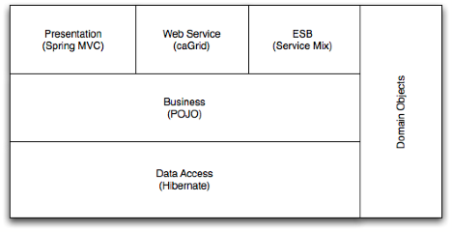

Domain Objects / Persistence
C3PR is purely domain driven, test driven development. There is no need for separate concerns on view layer, for instance, there is no need for separate view objects or separate persistence objects and mapping between all the objects. All of C3PR domain objects reside in the package edu.duke.cabig.c3pr.domain; the Design & Analysis starting from a BRIDG (Biomedical Research Integrated Domain Group) Harmonized model.

A foundational DomainObject interface is needed as a placeholder for all domain objects in the system, along with commonly needed attributes, such as Id. AbstractMutableDomainObject and AbstractImmutableDomainObject implement DomainObject and form a representation of persistent base domain objects.
Domain objects not only encapsulate the state, but also have basic behavior (such as adding/removing collections) incorporated. Each domain object knows how to persist itself via Hibernate annotations, instead of using separate HBM files to map persistent objects to database.

Lastly, to facilitate convention over configuration, an improvedNamingStrategy is used in Hibernate’s session factory (configured in Spring). This enables fewer mapping annotations in domain objects for simple attributes, which follow conventions of Database pluralization:

</property>
<property name="namingStrategy">
<bean class="org.hibernate.cfg.ImprovedNamingStrategy" />
</property>

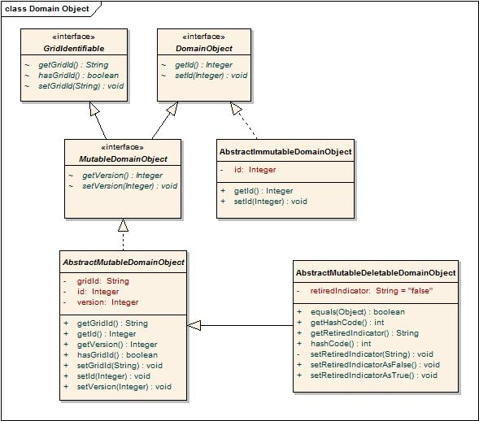
Figure 1: Domain Objects

Views
The view technology consists of JSP pages with standard stylesheets (CSS), JSP Tag libraries including Spring tag libraries, AJAX, DWR and Scriptaculous.

Controllers
Spring’s MVC is being used as the de-facto MVC architecture for C3PRv2. All the Controller classes for the respective use case will be located in the package edu.duke.cabig.c3pr.web

Commands
A set of command objects (Form objects) as per the Spring MVC which acts as a command for each controller. It is recommended to use domain objects as command wherever applicable to reduce the unnecessary creation of extra value objects.

Service Layer
The service layer will expose a set of interfaces for the client to call in (currently the interface decided is a Web Interface). The Controller classes typically delegate the functionality to Service classes. Spring adds the dependency injection for the implemented classes as Controller need not be coupled with the Service implementations.

Dao Layer
Hibernate is chosen for the persistence layer and all DAO implementations will specific to the domain objects being persisted. Leveraging Java 5.0 generics, each DAO class specifically caters to a domain object’s persistence by accepting a domain object type in the class definition. All Services/Controllers should be able to access the database only via a DAO object. Each implementation extends the
org.Springframework.orm.hibernate3.support.HibernateDaoSupport class that provides a good template for quickly building data access methods without the risk of database leaks and poor error handling.

DomainObjectDao interface is a place holder for generic operations. AbstractDomainObjectDao is an abstract class, which implements the DomainObjectDao interface and provides implementation for some of the methods, leaving other for subclasses:

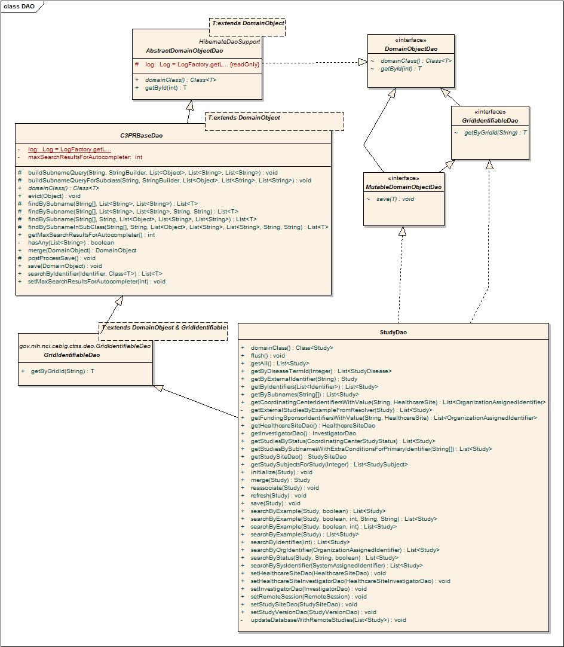
Figure 2:DAO

Core Modules

Dependency injection (Architectural Pattern)

The objects in different layers are connected or wired together using an architectural pattern called dependency injection/inversion of control. This means that, instead of a DAO object acquiring a data source from JNDI, or a controller finding a DAO using some sort of service locator, each object declares the objects (commonly referred to as collaborators) it depends on based on its own requirements. All the collaborators are instantiated by an external configuration tool; all their dependencies are satisfied by that tool when they are created.

Inter-layer dependencies are oriented such that higher levels depend on lower levels, but never vice versa. For instance, a service may depend on a DAO, but a DAO will never depend on a service.

C3PR uses the Spring Framework (version 2.0), specifically Spring IOC container for dependency injection, with the dependencies declared in a series of XML files included alongside the deployed classes. For more information about the Spring Framework, please see http://www.springframework.org/documentation.
The following diagram illustrates the wiring of various objects that belong to different layers in C3PRV2:

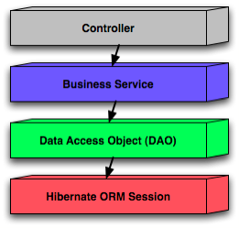
Figure 3: Spring wiring of C3PRV2 web app components

Open Session In View filter

A filter which implements the Open Session In View pattern. Different from the one built into Spring because this one delegates to an instance of OpenSessionInViewInterceptor configured in the application context. This permits the use of the same interceptor for deployed code & unit tests.

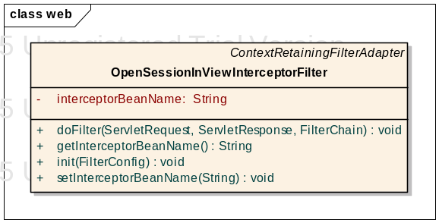
Figure 4: Open Session in View

Grid Identifiers

Grid Identifier servers as a unique identifier for persistent entities across different C3PR instances. For example, to be able to uniquely identify a Study object in C3PR instance A in Duke and another Study object (with the same semantics) in C3PR instance B at Mayo, the only way to uniquely identify is via a Grid Identifier.

In c3PR an interface is included to achieve this functionality – GridIndentifierCreator. Two different implementations exist for generating Grid Ids, one based on UUID (LocalGridIdentifier) and another based on caBig’s handler based grid ids.
Currently we are using LocalGridIdentifiers

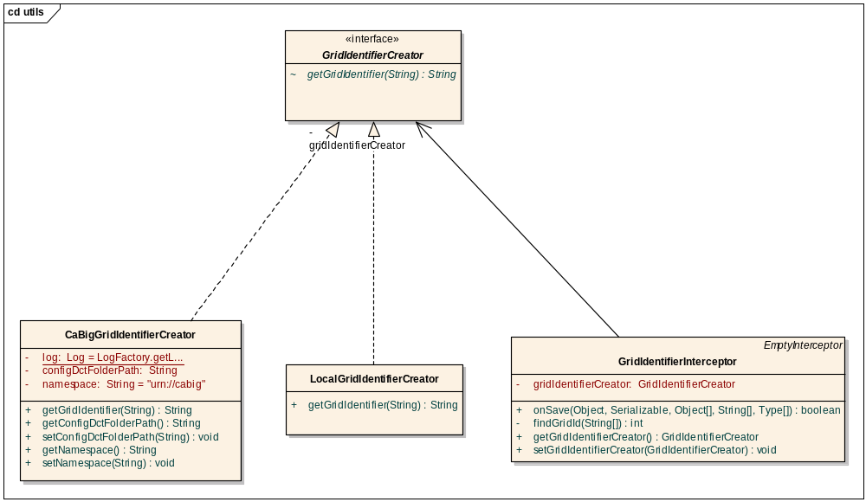
Figure 5: Grid Identifiers

Decorators (Sitemesh)
C3PR uses Sitemesh for rendering multiple layouts for various Screens. The advantage of Sitemesh is the flexibility of standardizing layouts across all workflows and ‘decorating’ pages with sub-flows on demand. For instance, Create Study and Edit Study can both reuse the same jsps for rendering the pages. As Edit Study Workflow further has more panels (such as Study Summary and Registrations), these panels will be rendered by the decorator without the knowledge of the corresponding Controller

Tag Libraries
Several Tag Libraries have been incorporated to generalize UI rendering, encouraging code reuse. This includes tag libraries for pages like Study Summary, Registration History, Search (Subject & Study) etc. Also generic tags for the following are incorporated:

Standard Header
Standard Footer
Standard Navigation

Validation
C3PRV2 validates all data that is being persisted in the system. Several validation frameworks are used at different layers of the application to do data validation. The diagram Error: Reference source not found illustrates the different frameworks we use in the different layers of c3pr. We use a validation framework called ctms-validation that is developed in the shared CCTS workspace. It provides annotation-based validation of domain objects that can be done in any layer of the application. We call these validators from the Spring Controller layer.

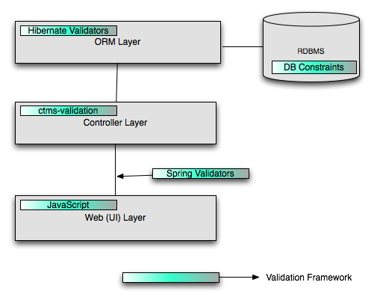
Figure 6: Validation

Dynamic Navigation Framework
A tag library for navigation across all UI pages has been incorporated. The Use of Spring Interceptors to intercept each HTTP request and render the Dynamic Menu is the key. Each Menu on the navigation is regarded as “Section” and MenuItem as “Task”. For more details refer the UML diagram

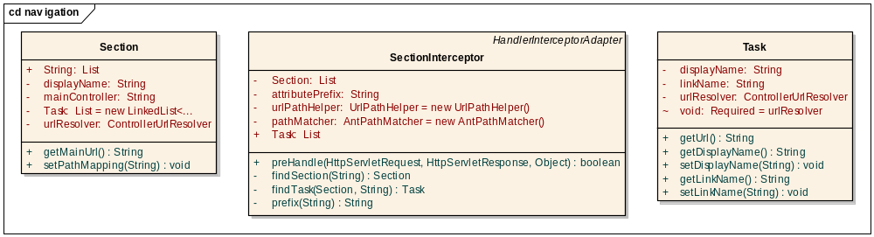
Figure 7: Dynamic Navigation

JavaScript
Wherever possible, Ajax is being used to provide dynamic interface to the users. DWR Engine helps to serialize/deserialize Ajax requests back & forth to the Server. For javascript, Scriptaculous library is being used.

Exception Handling
A basic exception handling framework is provided to capture and pass exceptions with user defined codes. Instead of allowing system defined exceptions to float between different layers, the framework forces to define business codes and messages corresponding to those codes in a property file. An ExceptionHelper class is provided to get CodedException objects which can then be thrown between layers. This ensure that at any time the exceptions, that are visible to any layer are business exception with user defined codes and messages.

Domain Analysis Model
The domain analysis model for C3PR is based on a BRIDG.

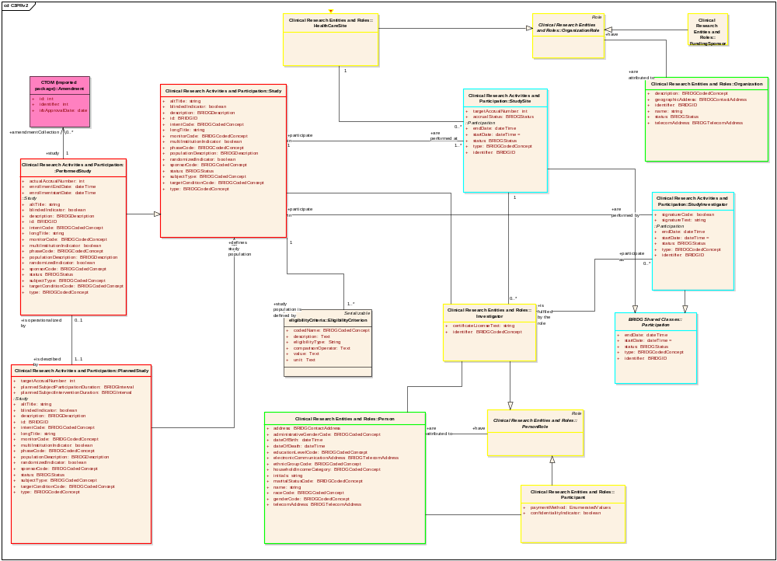
Figure 8: BRIDG

Implementation Model
Derived from Domain Analysis model, the implementation model is a model realized for a Java implementation with classes, associations. For a complete UML model, refer the Domain model section in c3pr-uml design in appendix

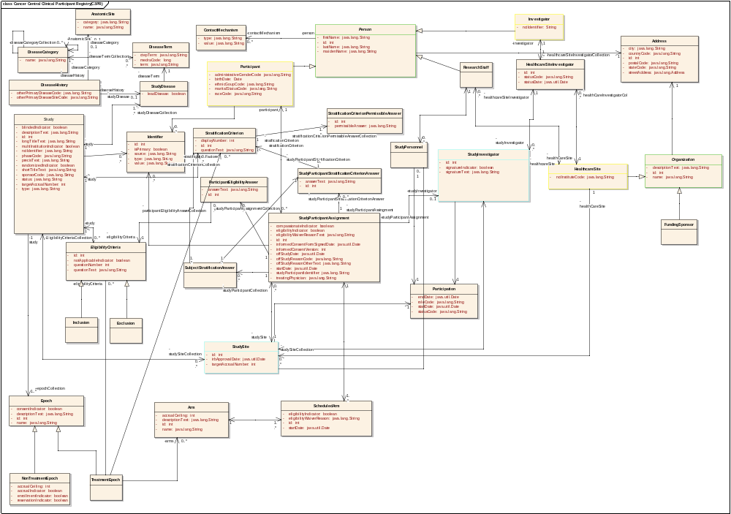
Figure 9: Implementation Model

Data Model
C3PR is currently tested for Oracle 10x/Postgres 8x databases

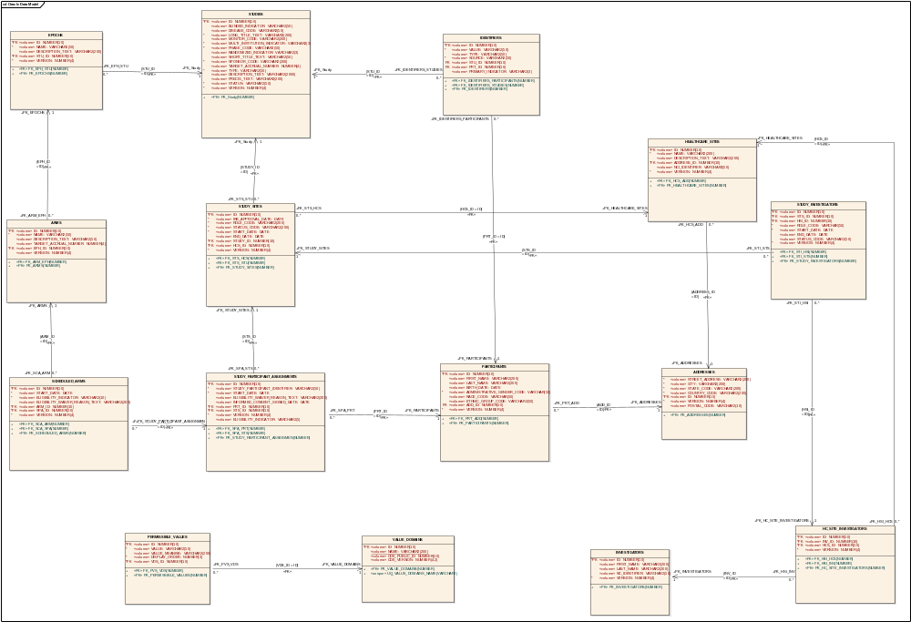
Figure 10: Data Model

Use Case Realization

Create Study
This use-case deals with the manual creation of a study by entering each data element of the study.

Domain Objects Used

Study
Epoch
Arm
Randomization
EligibilityCriteria
StratificationCriterion
StudySite
StudyDisease
Identifier
Healthcare
Investigator
StudyPersonnel
Companion

Activity Diagram
The workflow is split into multiple pages in a Wizard style for capturing individual pieces of information for simplifying the workflow of Study creation

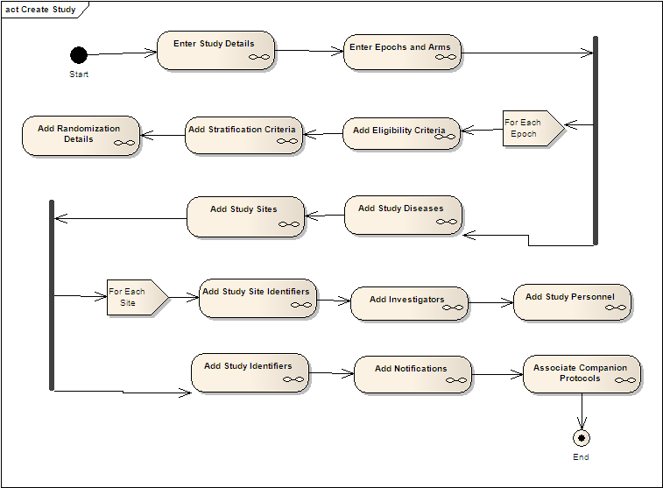
Figure 11: Create Study Activity

Sequence Diagram
Core controller of Create Study is based on Spring’s AbstractWizardFormController. This eliminates the session/form handling by the developer and provides fine extension points for generating a workflow between a well defined set of pages with the notion of back/next buttons. The validations used on the page are two level – client side javascript and server side Spring validations (to be done only on the last page).

The command object used for the controller is the domain object itself. The advantages of this design is that there are no unnecessary value objects/DTOs used in the whole process and the emphasis is on reusing rich domain objects across all layers in the appropriate context. The View saves individual elements of Study object within each page of the workflow (wizard) dynamically and on the last page the entire graph of Study object along with it’s associations of StudySite, Identifiers, Epochs, Arms are saved. Spring’s HibernateTemplate is used to saveOrUpdate the populated domain object

Spring Validators are used for simple business validations on the server side. The Controller’s validate() method takes the central place to delegate validations to individual validation of domain objects (Study, Epochs, Arms etc)

Create Study use case also involves asynchronous messaging via the ESB client inteface: ServiceMix and GridServices are used to propagate the newly created Study to other systems.

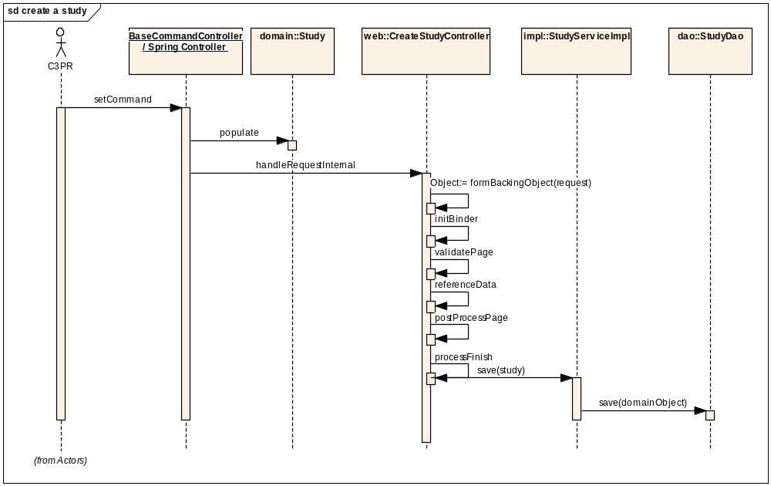
Figure 12: Create Study Sequence

Search Study
This use-case deals with searching an existing Study either by status, long title or by one of the Identifiers

Domain Objects Used

Study

Activity Diagram
User is provided with a simple Form where search criteria can be entered (includes wildcards); search results are displayed in a separate search results page with an option of searching from the same page via an intuitive search bar on the top of search results page

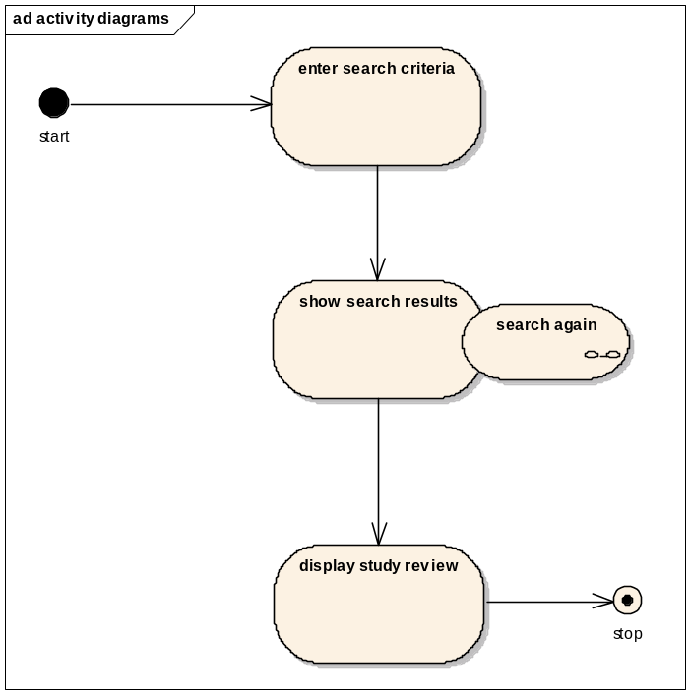
Figure 13: Search Activity

Sequence Diagram
As it’s a simple search, a SimpleFormController is being used for implementing the behavior of
Search->SearchResults page. Hibernate’s SearchByExample is being used to search using an example object populated with the user’s dynamic criteria.

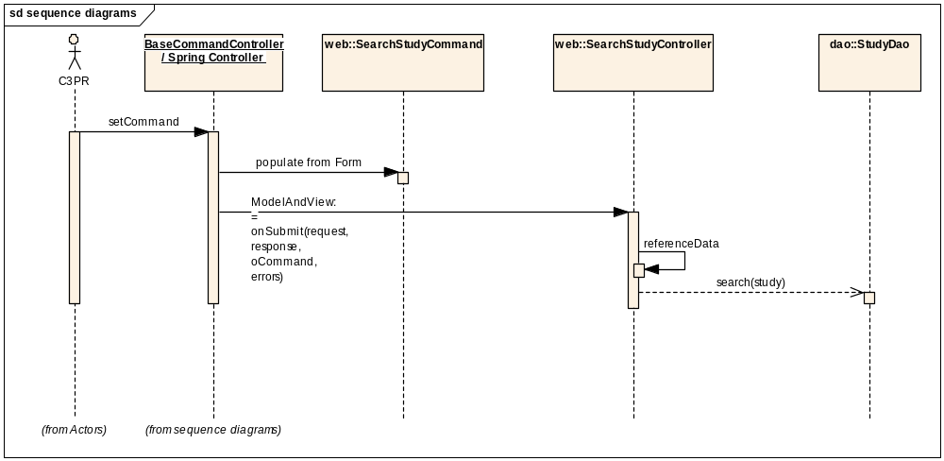
Figure 14: Search Sequence

Edit Study
This use case deals with updating the existing Study once the user searches for a study. The user can view the complete details of Study as well as update individual identifiers, study sites, design, and so on.

Domain Objects

Study
Epoch
Arm
Randomization
EligibilityCriteria
StratificationCriterion
StudySite
StudyDisease
Identifier
Healthcare
Investigator
StudyPersonnel
Companion

Activity Diagram
Edit Study use case is similar to the Create Study use case, except that in Edit Study form fields are pre-populated with the existent study’s details, which user can modify. The activity diagram is also similar to the one for Create Study:

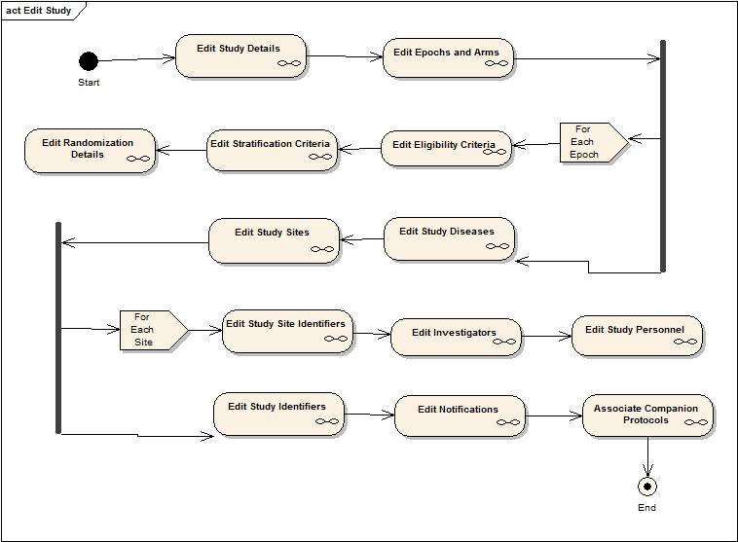

Sequence Diagram

Core controller of Edit Study is based on Spring’s AbstractWizardFormController. This eliminates the session/form handling by the developer and provides fine extension points for generating a workflow between a well defined set of pages with the notion of back/next buttons. The validations and other functionality works similar to that of Create Study Controller. The command object used for the controller is the domain object itself.

The main difference between Edit Study and Create Study is the loading of entire Study object in the formBackingObject. Once the user has selected a study in the previous screen, the edit screen should be loaded with Study details in the Web Session. It is to be noted that Lazy loading of collections is not recommended as Hibernate objects need to be detached and reattached in case of update in the Web layer. By loading the entire graph into memory before the page is accessed, we simplify the design. And because the Study domain objects are not data-heavy, we are still able to achieve acceptable performance. Spring’s HibernateTemplate is used to saveOrUpdate the populated domain object.

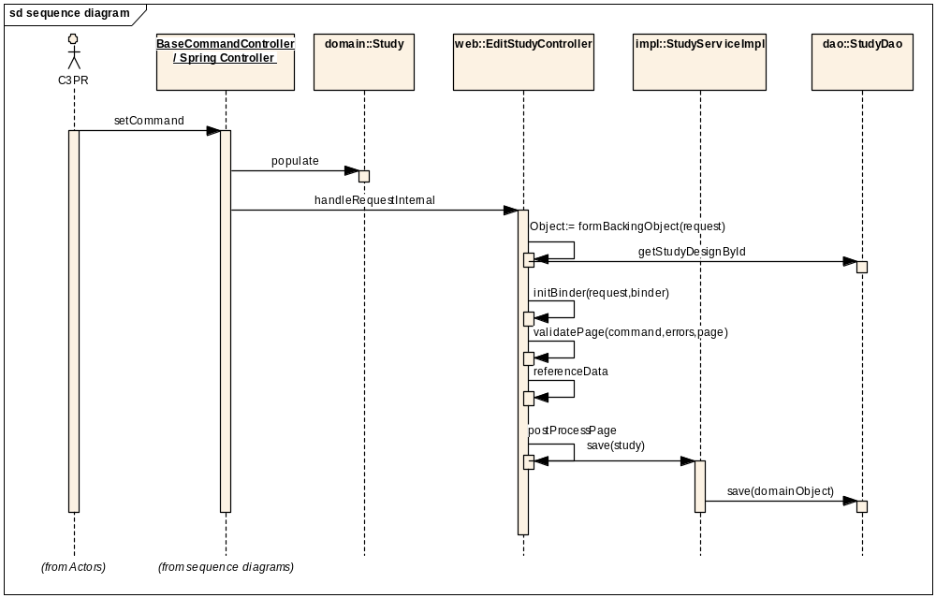

Create Subject
This use-case deals with the manual creation of a subject by entering each data element of the subject

Domain Objects

Participant
Person
Address
Identifier
StudyParticipantAssignment

Activity Diagram
The workflow is split into 3 tabs using a Wizard form controller for capturing individual pieces of information about the subject. In the first tab, the basic subject details and the subject’s identifiers are entered. In the 2nd tab, the subject’s addresses are entered. The third tab is for reviewing and submitting all the information.

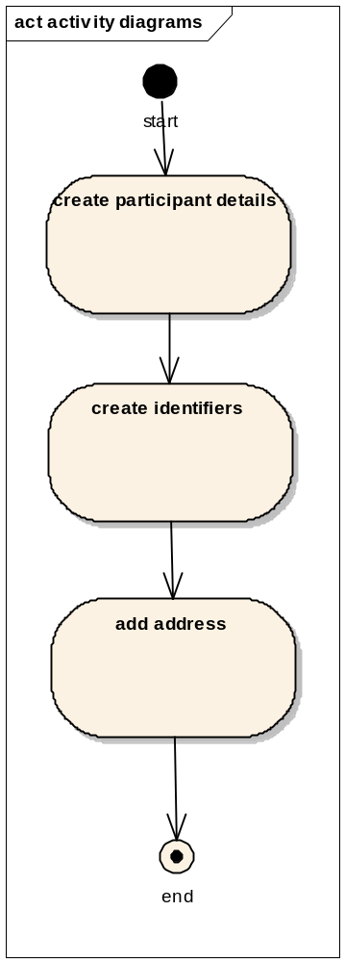

Sequence Diagram
Core controller of Create Subject is based on Spring’s AbstractWizardFormController. This eliminates the session/form handling by the developer and provides fine extension points for generating a workflow between a well defined set of pages with the notion of back/next buttons. The domain object acts as the command Object. The CreateParticipantController invokes the services of ParticipantServiceImpl. The ParticipantServiceImpl uses the ParticipantDao class for persisting the participant Object.

Spring Validators are used for simple business validations on the server side. The Controller’s validate() method takes the central place to delegate validations to individual validation of domain objects (Participant)

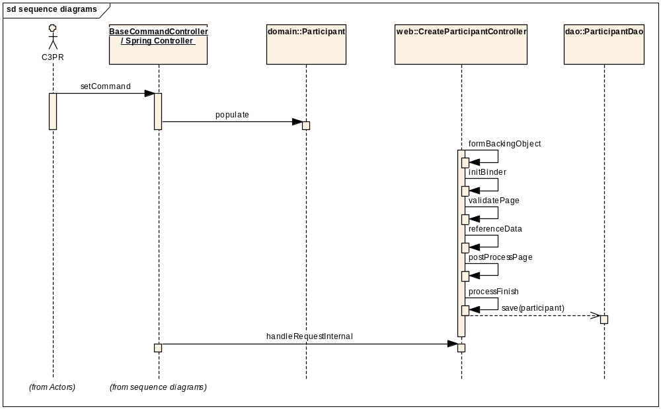

Search Subject
This use-case deals with searching an existing Subject either by last name or by one of the Identifiers.

Domain Objects

Participant

Activity Diagram
User is provided a simple Form where search criteria can be entered (includes wildcards), search results are displayed in separate search results page with an option of searching from the same page via an intuitive search bar on the top of search results page

- 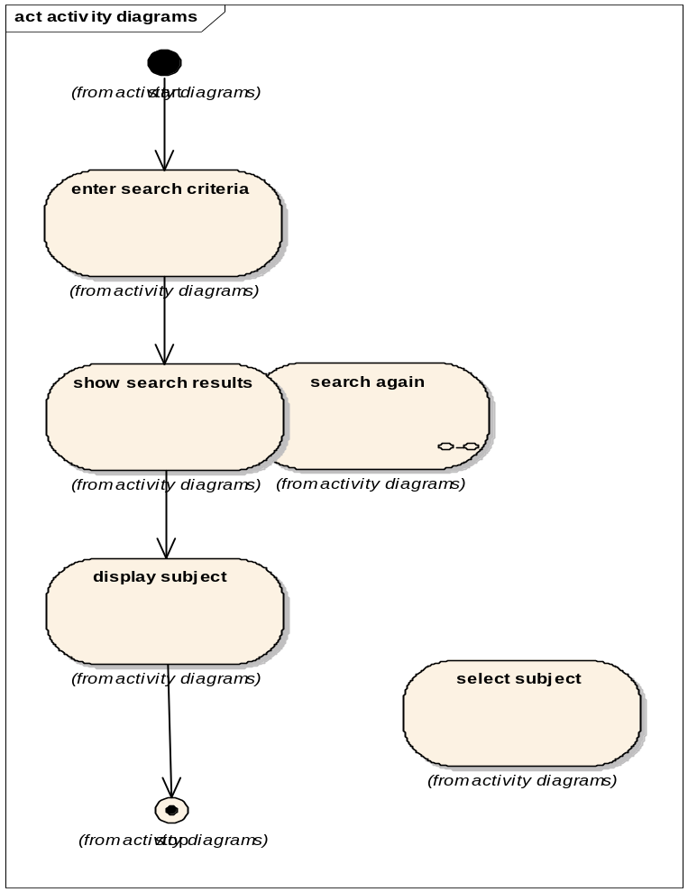

Sequence Diagram
A SimpleFormController is being used for implementing the behavior of Search->SearchResults page. Hibernate’s SearchByExample is being used to search using an example Subject object populated with the user’s dynamic criteria.

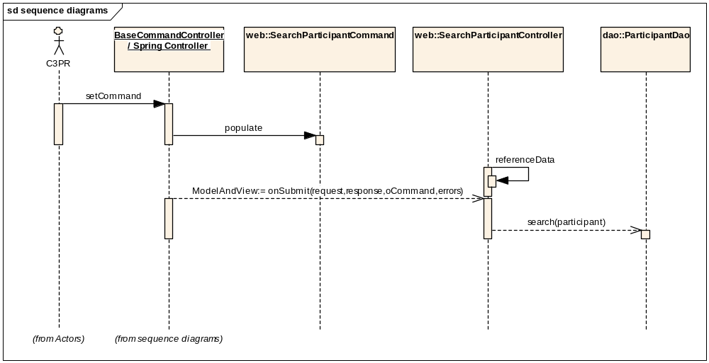

Edit Subject
This use case deals with updating the existing Participant once the user searches for a participant. The user can view the complete details of Participant as well as update individual identifiers, addresses, contact info

Domain Objects
Participant
Person
Address
Identifier
StudyParticipantAssignment

Activity Diagram
Edit Subject use case is similar to the Create Subject use case, except that in Edit Subject form fields are pre-populated with the existent subject’s details, which user can modify. The activity diagram is also similar to the one for Create Subject:

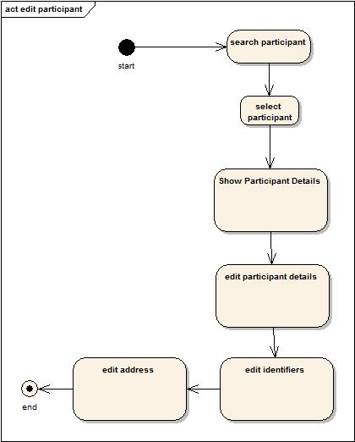

Sequence Diagram
Core controller of Edit Participant is based on Spring’s AbstractWizardFormController. This eliminates the session/form handling by the developer and provides fine extension points for generating a workflow between a well defined set of pages with the notion of back/next buttons. The validations and other functionality works similar to that of Create Participant Controller. The command object used for the controller is the domain object itself.

The main difference between Edit Participant and Create Participant is the loading of entire Participant object in the formBackingObject. Once the user has selected a study in the previous screen, the edit screen should be loaded with Participant details in the Web Session. It is to be noted that Lazy loading of collections is not recommended as Hibernate objects need to be detached and reattached in case of updation in the Web layer. By loading the entire graph before the page is called simplifies the design for simultaneous view/update as Particpant objects are not intensive in data (still fine with performance). Spring’s HibernateTemplate is used to saveOrUpdate the populated domain object

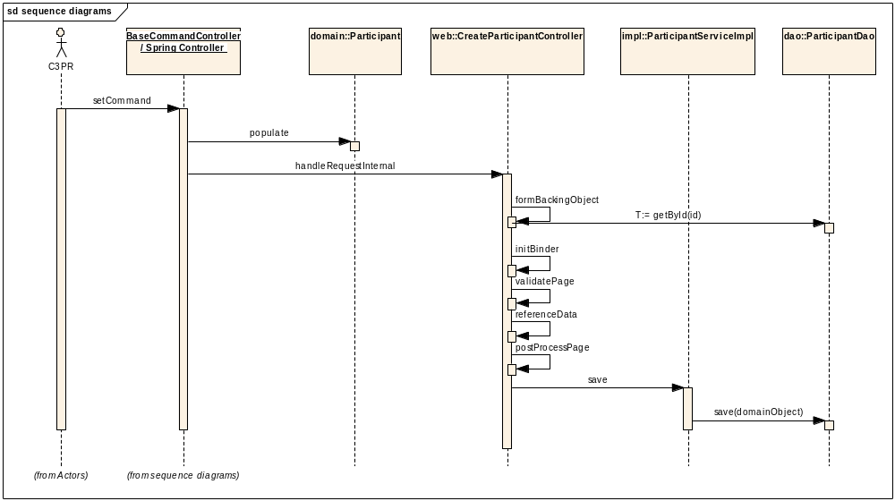

Register Subject to Multi-Site Study
This use case deals with registering a patient to a study being conducted at multiple sites. This use case from the perspective of the C3PRV2 system involves the following

Notifying the coordinating Site - The C3PRV2 system at the local site will notify the coordinating center of the multi-site study, of a new patient registration. It is assumed that the registration flows from the local site to the coordinating site. In this case the C3PRV2 system at the local site sends a notification of the new registration

Consuming the notification - The C3PRV2 system at the coordinating site will then receive and process this notification. Notification denotes a message that describes the patient registration that has taken place at a local site

Domain Objects

StudySubject
Study

Activity Diagram

This following activity diagram captures the sequence of events happening at both the local site and the coordinating site during the registration of a patient to a multi-site study:

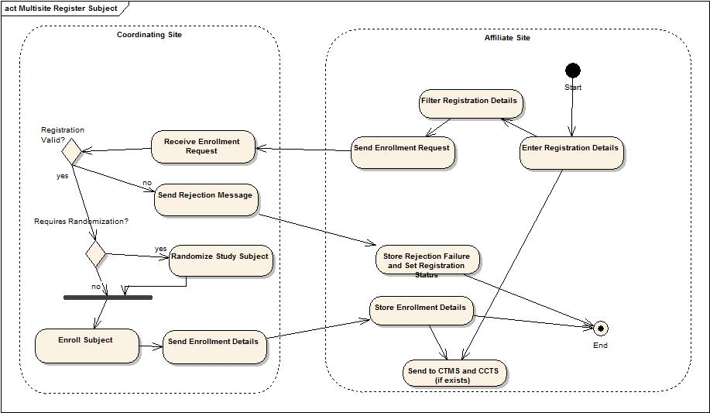

Sequence Diagram

The following sequence diagram captures the sequence of events at both the coordinating center and the local site:

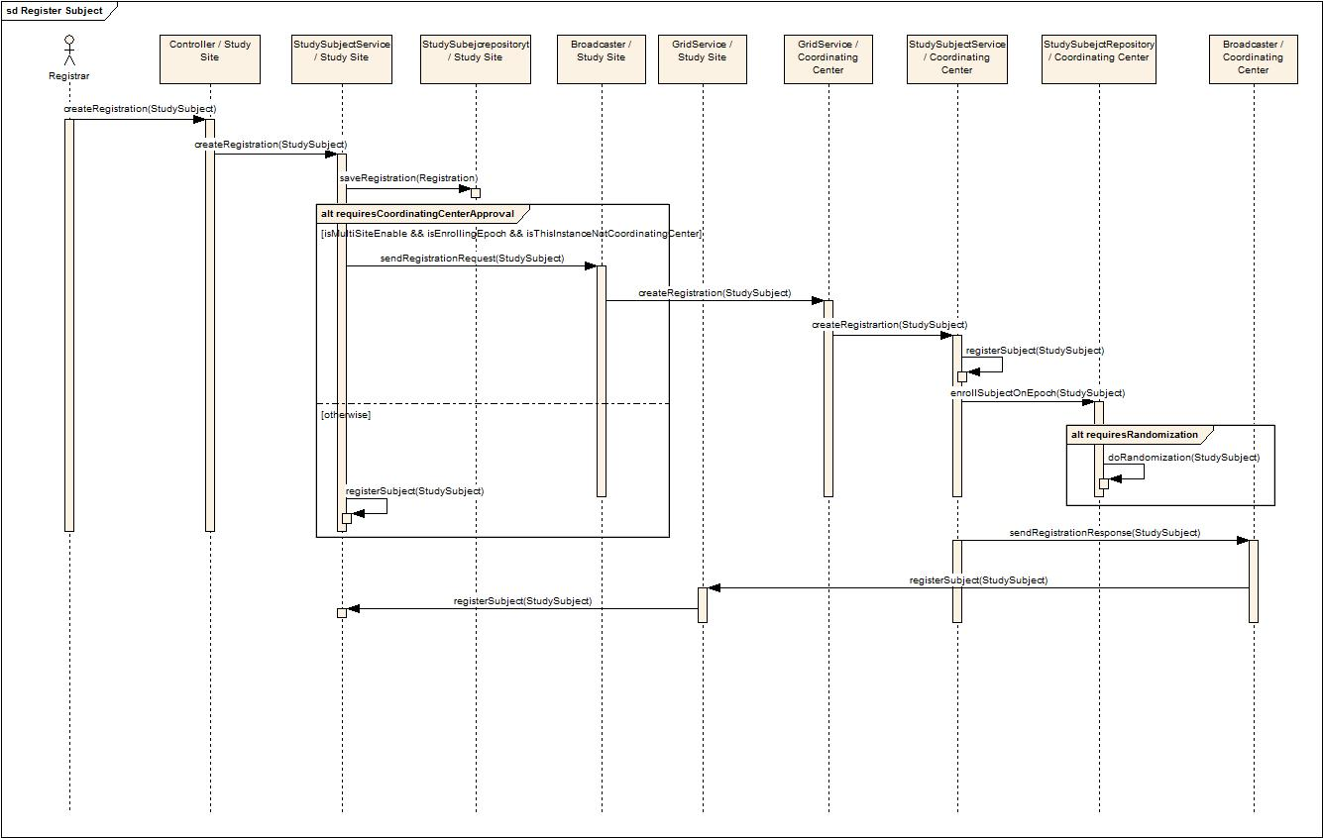

Register Subject to a Study
This use case deals with registering a participant with a study at a study site. The following are the various scenarios possible:

Patient not currently in C3PR.
Patient already existing in C3PR but not registered to any protocol.

Domain Objects

StudySubject
Study

Activity Diagram
The workflow is split into multiple pages in a Wizard style for capturing individual pieces of information for simplifying the workflow of Registration.

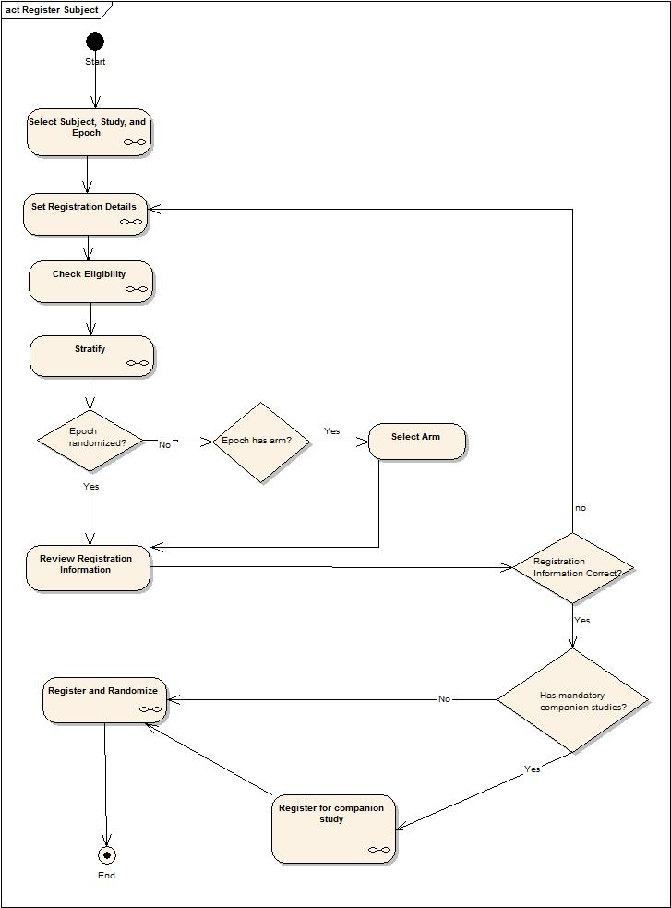

View/Update Registration Details
This use case deals with viewing a subject’s registration details, updating registration identifiers, changing the eligibility status, viewing stratification information, getting an arm from randomization and updating registration status. This use case from the perspective of the C3PRV2 system involves the following

Domain Objects

StudySubject
Subject
EnrollmentDetails
Identifier

Activity Diagram

This following activity diagram captures the sequence of events that happen in update registration details process.
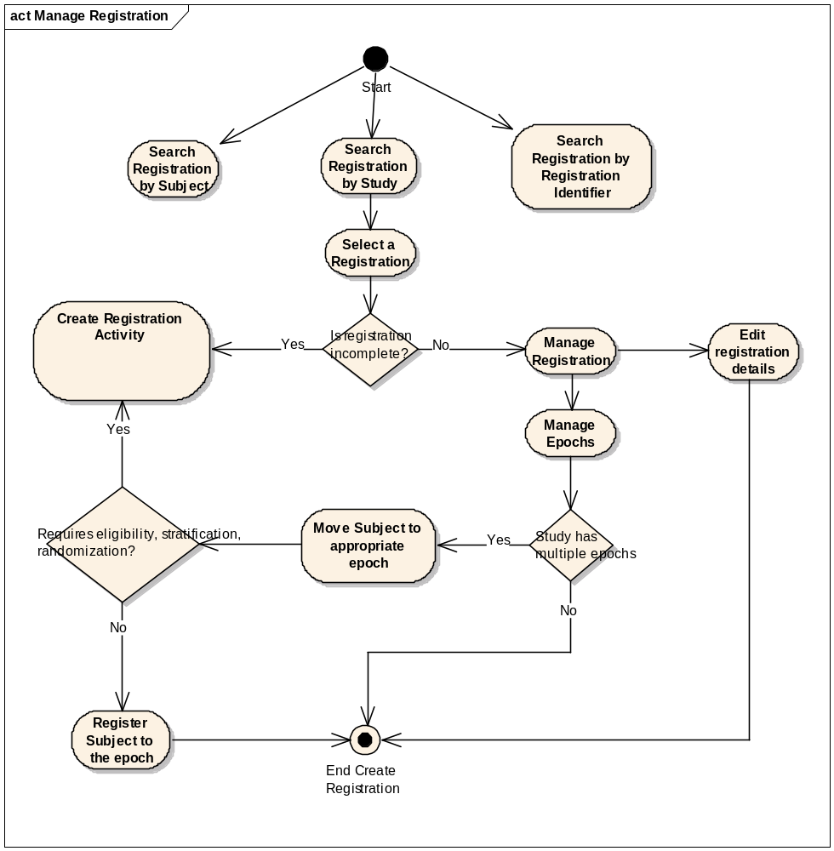

Sequence Diagram

Core controller of manage registration details is ManageRegistrationController which extends RegistrationController, which in turn is derived from AutomaticSaveFlowFormController. Edit Registration Flow is initialized and tabs are added to the flow. Tabbed Flow Controller automatically manages the tab numbering and the page flow. The domain object, StudySubject is used as the command object.

The main difference of Edit Registration with respect to Create Registration is the loading of entire StudySubject object in the formBackingObject. Once the user has selected a registration from a set of registrations, the edit screen is loaded with Subject summary, registration details and study summary in the Web Session. It is to be noted that Lazy loading of collections is not recommended as Hibernate objects need to be detached and reattached in case of updation in the Web layer. By loading the entire graph before the page is called simplifies the design for simultaneous view/update. Spring’s HibernateTemplate is used to saveOrUpdate the populated domain object

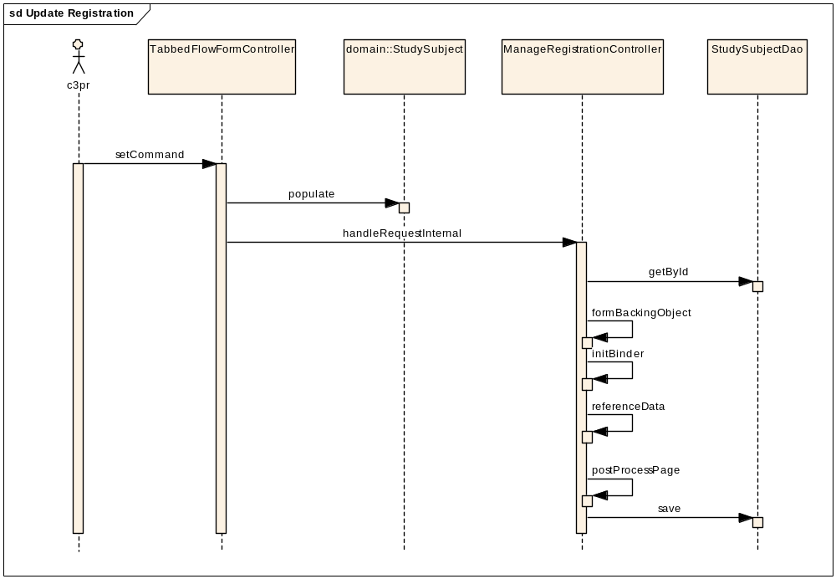

Manage Registration Status
When a subject is registered on a study, the registration record can go through various phases of data entry and workflow which together affect the complete status of the registration record.

C3PR defines two primary categories of status to manage registration:
Registration Status : pertaining to a registration
Epoch Status : pertaining to assignment of a subject on a epoch

The following table describes the different status and its description:

Registration Status
Date Entry Status
Status | Entry Criteria
Incomplete | If all the mandatory fields are not filled in by the user
Complete | If all the mandatory fields are filled in by the user
WorkFlow Status
Status | Entry Criteria
Unregistered | If all the mandatory fields are not filled in by the user
Pending | If the registration is for a multi-site trial, and the registration is sent to the Co-ordinating center but the response is not yet arrived.
Disapproved | Local Study:  -> If accrual ceiling is reached.  MultiSite Study:  ->If the registration is for a multi-site trial, and Co-ordinating center disapproves it.
Reserved | If the registration is on a Non-Treatment Enrolling epoch which has reservation indicator set to true.
Registered | Local Study:  -> If registration requires Randomization, and Randomization is done successfully.  -> If registration is on Non-Treatment Epoch.  MultiSite Study:  ->If the Co-ordinating center responds with a successful registration message.

Scheduled Epoch Status
Date Entry Status
Status | Entry Criteria
Incomplete | If all the mandatory fields are not filled in by the user
Complete | If all the mandatory fields are filled in by the user
WorkFlow Status
Status | Entry Criteria
Unapproved | If all the mandatory fields are not filled in by the user
Pending | If the registration is for a multi-site trial, and the registration is sent to the Co-ordinating center but the response is not yet arrived.
Disapproved | Local Study:  -> If accrual ceiling is reached.  MultiSite Study:  ->If the registration is for a multi-site trial, and coordinating center disapproves it.
Approved | Local Study:  -> If registration requires Randomization, and Randomization is done successfully.  -> If registration is on Non-Treatment Epoch.  MultiSite Study:  ->If the Co-ordinating center responds with a successful registration message.

The following state diagram shows the transition (entry-exit criteria) of the various statuses a registration can enter:

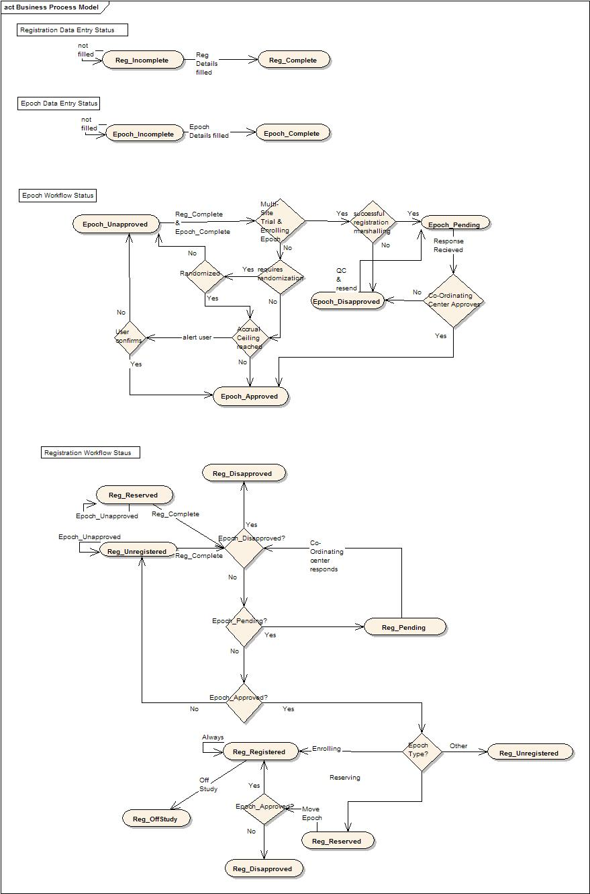

Integration with External Systems

ESB Client
C3PR Service interacts with an ESB client for messaging in order to pass on the data created (new Study, registration etc) to other instances of C3PR, as well as other external applications. More information about the design of ESB can be found in the technical design of ESB

Unit Testing

JUnit
JUnit framework will be used for unit testing. DbUnit forms the core part of the unit testing framework to setup/delete test data XML before running each test case. C3PR uses custom classes written over DbUnit test package providing more utility methods for unit testing in each layer (Controller, Dao etc). Currently, C3PR has test cases at 2 levels, the Dao layer and the Web layer. Each DaoTest extends DaoTestCase, which extends DbTestCase, which in turn extends DatabaseTestCase. Before each test case is run, the DbUnit cleans up the database so that each test starts on a clean slate to make sure there are no errors introduced due to bad data or due to dependencies. All the test data XML can be found in the package edu.duke.cabig.c3pr.dao.testdata. The database settings are externalized and specified in the file database.properties, which is to be found in core/conf. Other utility classes like ContextDaoTestCase, DaoTestCase, and ApplicationTestCase can be found in the package edu.duke.cabig.c3pr.utils.
Similarly at the web layer, each controllerTest extends ControllerTestCase, which inherits from WebTestCase, which in turn extends ApplicationTestCase. Mocks are registered for the HttpServletRequest, HttpServletResponse, ServletContext, Session, the Dao layer etc using springframework’s support for creating mocks. The controllers are tested for the correctness of the reference data, for handling the HttpServletRequest, HttpServletResponse, and for generating correct view. The test cases for the controllers and the command classes can be found in the package edu.duke.cabig.c3pr.web. The beans in the ApplicationContext*.xml are loaded using edu.duke.cabig.c3pr.utils.ContextTools.

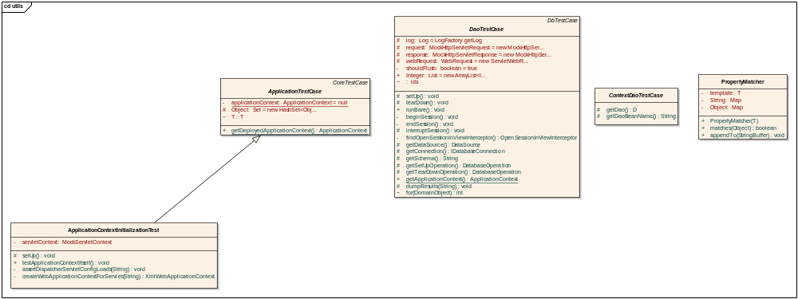

Mock Objects
Use of Spring mock objects for mocking the dependent layers like Controller, Dao, Services

Integration Testing
Integration Testing will be achieved via JUnit/Haste frameworks. This is integrated with the main build file.

Configuration/Build/Deployment
The files in the Core/Web projects will be build through the main build file (build-core & build-web individually). For all other builds like build-tests, the individual build files of these projects have corresponding ant tasks
- References
No | Artifact | Type | Link
1 | GForge CVS Repository | CVS Repository | gforge.nci.nih.gov
2 | c3pr_uml.eap | UML Design | gforge.nci.gov
3 | C3PRv2-BRIDG.EAP | Domain Model | gforge.nci.nih.gov
4 | C3prv2_use_cases.doc | Use Cases | gforge.nci.nih.gov
5 | c3prv2_technical_architecture.doc | Architecture | gforge.nci.nih.gov
6 | c3prv2_technical_specification_Integration | Architecture | gforge.nci.nih.gov
7 | C3prv2_srs.doc | SRS | gforge.nci.nih.gov
8 | c3prv2_technical_spec_servicemix.doc | design | gforge.nci.nih.gov

- Glossary
Term | Definition
CSM | Common Security Module
IdP | Identity Provider
API | Application Programming Interface
CDE | Common Data Element
GUI | Graphical User Interface
UML | Unified Modeling Language
JMS | Java Message Service
API | Application Programming Interface
caBIG | cancer Biomedical Informatics Grid
DAO | Data Access Objects
HTTP | Hypertext Transfer Protocol
JDBC | Java Database Connectivity
JSP | JavaServer Pages
ORM | Object Relational Mapping
RDBMS | Relational Database Management System
SDK | Software Development Kit
HASTE | High-level Automated System Test Environment
WSRF | Web service resource framework
ESB | Enterprise Service Bus
AJAX | Asynchronous JavaScript a
BC | Binding Component
SE | Service Engine
NMR | Normalized Message Router
JAAS | Java Authentication and Authorization Service
GAARDS | Grid authentication and authorization with Reliably Distributed Services
DWR | Direct Web Remoting

